Mapping Different Software Architecture Paradigms to Different Integration Techniques: Highlighting Driving and Restraining Forces for Each Paradigm
- M. Riad, Hazem M. El-Bakry, Haitham A. El-Ghareeb *^{Corresponding author}
Information Systems Department, Faculty of Computers and Information Sciences
Mansoura University, Egypt
amriad2000@mans.edu.eg, hazemelbakry1@yahoo.com , helghareeb@acm.org

Abstract
Technical agility refers to the ability to quickly change the type and flow of information within an enterprise. Technical agility parameters are affected by enterprise architecture. IT advance has not yet satisfied business requirements due to improper software architectures. SOA addresses technical agility requirements by presenting composability, modularity, and loose coupling concepts as services that wrap underlying IT infrastructure, databases, and legacy systems and present them via standard interface. There is a need to stabilize IT infrastructure rather than developing new ones and SOA enables this stabilization. Enterprises should balance IT to become better positioned and more agile. Services are the building Blocks of an agile enterprise.
This paper discusses the importance of enterprise architecture in meeting systems’ non-functional requirements and examines different software architecture paradigms, driving and restraining forces for each one in meeting systems integration as one of the most desirable requirement. Integration has different techniques, and different software architecture paradigms can address different techniques. This paper presents a proposed mapping of different software architecture paradigms to different integration techniques while highlighting driving forces that encourages software architects to utilize it and restraining forces that discourages architects from utilizing them.
Keywords

- Introduction
It has become accepted that there is a clear need for an ‘architectural view’ of systems [1]. Enterprise Architectures that satisfies nowadays enterprises’ requirements should be presented. Software architecture is one class of enterprise architecture that should address organizational requirements like system’s interoperability, integration, agility, and other requirements [2,3]. The architectural view of systems (both business and IT systems) is defined in ANSI/IEEE standard 1471-2000 as “the fundamental organization of a system, embodied in its components, their relationships to each other and the environment, and the principles governing its design and evolution”. Enterprises can be thought of as the combination of business needs, and IT capabilities. Agile organizations are those where IT serves business needs, not limiting it [4].
  - Enterprise Architecture Dimensions
Different dimensions of the enterprise need to be defined in order to generate the enterprise architecture. From enterprise point of view, architectures are classified into four categories [2]: Business Architecture, Information Technology (IT) Architecture, Information Architecture, Application (software) Architecture as depicted in figure 1. Enterprise architecture tends to define the enterprise from the four dimensions in order to connect between them and present a complete view for the enterprise

Software Architecture, Integration, Integration Methods, Integration Techniques, Service Oriented Architecture (SOA)
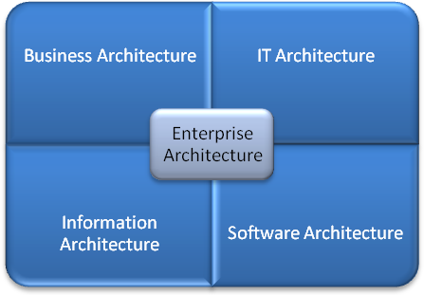
Figure 1. Enterprise Architecture Dimensions
    - Business Architecture
A business or business process architecture defines the business strategy, governance, organization, and key business processes within an enterprise. The fields of Business Process Reengineering (BPR) and Business Process Management (BPM) focus on the analysis and design of business processes, not necessarily represented in an IT system [2]. Business Architecture defines the business roadmap usually via defining the business processes [5].
    - IT Architecture
The IT architecture defines the hardware and software building blocks that make up the overall information system of the organization [2]. IT architecture includes hardware and software infrastructure including database and middleware technologies. The IT architecture should enable achievement of the business goals using a software infrastructure that supports the procurement, development, and deployment of core mission-critical business applications. The purpose of the IT architecture is to enable a company to manage its IT investment in a way that meets its business needs by providing a foundation upon which data and application architectures can be built.
    - Information Architecture
The data architecture of an organization includes logical and physical data assets and data management resources. Information is becoming one of the most important assets a company has in achieving its objectives, and the IT architecture must support it. Information Architecture spans Business and IT Architectures, brings them together, keeps them together, and provides the necessary rich contextual environment to solve the ubiquitous data-quality problem [6].
    - Software Architecture
Application architecture serves as the blueprint for individual application systems, their interactions, and their relationships to the business processes of the organization. A software application is a computer program or set of programs that uses existing technologies to solve some end-user problem such as the automation of an existing business process. Software architecture can be defined as “the sum of the nontrivial modules, processes, and data of the system, their structure and exact relationships to each other, how they can be and are expected to be extended and modified, and on which technologies they depend, from which one can deduce the exact capabilities and flexibilities of the system, and from which one can form a plan for the implementation or modification of the system” [7]. Application Architecture defines the form and function of the applications that will be developed to deliver the required functionality of the system [1].
Enterprise Architecture classes utilize each other, and build over each other. Distinctions between classes are blurred because they all serve each other, and serve the enterprise. Enterprise Architecture classes’ utilization can be thought of as depicted in figure 2. Common software architectures are presented in order to address the architecture that might solve most well known software architecture limitations; like lack of scalability, integration, and interoperability with different information systems. From this point on, Software Architecture and Architecture will be used interchangeably to refer to Software Architecture.
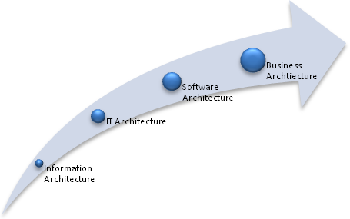
Figure 2. Enterprise Architecture Classes' Utilization
This paper goes as follows: Section Two presents the relation between Software Architecture and Systems’ Non-Functional Requirements. Section Three discusses the importance of Software Architecture. Section Four lists the most common Software Architecture Patterns while in Section Five authors present “Integration” as the selected criteria for comparing between different patterns. Section Six maps the different integration techniques and different Software Architecture Patterns; highlighting the driving and restraining forces for utilizing each one. Conclusion is presented in Section Seven with a proposed map between different integration techniques and software architecture patterns. Section Eight present References.
- Software Architecture and System Design
There are aspects that should be designed within any system. Those aspects are: Architecture, Functionality, and Presentation as depicted in figure 3. System design include: Architecturally defining subsystems and their functions, defining interface(s) for each subsystem and determining how those subsystems will interact, and allocating those subsystems to different components, as defined in [8].
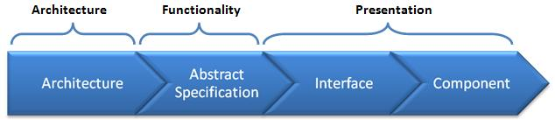
Figure 3. Architecture Design is one aspect of System Design
Each of System Design’s steps includes one or more functionalities. Functionalities can be mapped to system design steps as follows:
- Architectural Design: includes identifying and documenting sub-systems making the system and their relationships.
- Abstract Specification: includes producing an abstract specification of each sub-system’s services and the constraints under which it must operate.
- Interface Design: includes defining each subsystem’s interface with other sub-systems is designed and documented.
- Component Design: includes allocating services to different components and designing interfaces of these components.
Architecture is one aspect of a system to be designed, as well as the presentation of information and the functionality of the system. System requirements are either functional or non-functional [7]. Functional requirements are statements of services that systems should provide. Non-functional requirements present requirements that arose as a result of functional requirements. Architecture design is one step of system’s design that shall satisfy non-functional requirements as it satisfies functional requirements [2]. Some of the non-functional requirements that shall be satisfied by architectural design are presented in figure 4.
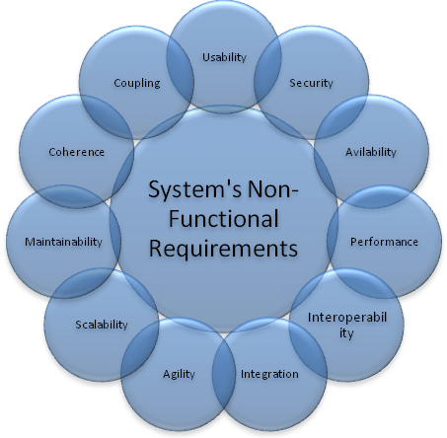
Figure 4. System’s non-functional requirements
- Importance of Software Architecture
Software architecture matters because a good one is a key element to success [7]. Though the fact that Systems have architectures but architectures are not systems [2] does not decrease architectures effects on systems. Some of the ways that software architecture influences success are [7]:
- Longevity: It is important to take time defining a good architecture because Architectures live longer than teams created them expects.
- Stability: Architectural stability helps ensure a minimum of fundamental rework as the system's functionality is extended over multiple release cycles, thus reducing total implementation costs.
- Degree and Nature of Change: Architecture determines the nature of change within the system. Some changes are perceived as applicable; others are perceived as not applicable.
- Profitability: Profitable architecture is the sustainable architecture within an acceptable cost.
- Social Structure: Architectures helps strengthening and weakening the social structure of the team. Teams can make social benefits form architectures during project time.
- Boundaries Defined: During the architectural design process the team makes numerous decisions about what is "in" or "out of" the system. These boundaries, and the manner in which they are created and managed, are vital to the architecture's ultimate success.

- Common Software Architecture Patterns
An Architecture Pattern expresses a fundamental structural organization or schema for software systems. It provides a set of predefined subsystems, specifies their responsibilities, and includes rules and guidelines for organizing the relationships between them [9]. Software architecture patterns can be divided into two categories: Data flow and Control flow [7,10]. Data Flow category focuses on functional modules and data transfers, while Control Flow category describes the way control is passed from one part of the system to the other. Table 1 lists both Data and Control Flow common architecture patterns.
Table 1. Common Software Architecture Patterns
[8 – 29]
Common
Software Architecture
Patterns
Data Flow | Control Flow
Model-View-Controller | Call And Return a.k.a. Main program And Subroutines
Presentation-Abstraction-Control | Implicit Invocation a.k.a. Event Based
Pipe-And-Filter | Manager Model
Layered Systems | Emulated Parallel
Microkernel
Client-Server
N-Tier
Repository
Blackboard
Finite State Machine
Process Control
Multi Agent System
Service Oriented Architecture
Master-Slave
Interpreter
Message Broker
Message Bus
Structural Model
Peer-to-peer
- Non-functional requirements
Shortages, limitations, and deficiencies of information systems that include lack of agility support and limitations of integration and interoperability are two of the non-functional requirements category. Integration is the main challenge with institutions, and it will be tested against the mentioned software architectures presented in table 1 as an indicator for the architecture satisfaction of non-functional requirements.
  - Integration
Application integration is a strategic approach to binding many information systems together [30]. The need to integrate applications has been a requirement since business process automation was presented [31]. Application integration can be one of the forms: Internal Application Integration, External Application Integration, or Enterprise Application Integration (EAI) [32]. Internal application integration techniques integrate organizational applications with each other, while external application integration techniques consider integrating organizational applications with applications outside organizational boundaries. EAI platforms centrally integrate heterogeneous system landscapes on process, method and data level [33]. Internal and External Application Integration present traditional integration levels, where EAI presents recent integration levels. Figure 5 depicts different integration levels as presented in [31].

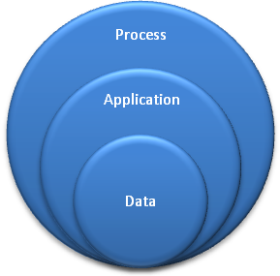
Figure 5. Integration Levels
Data level integration allows data to be shared among applications without sharing its application logic. Application level integration integrates applications by getting both connected applications’ logic aware and enablers of exchanging data. Process level integration presents a new level of integrating applications where integration here facilitates or presents a new business processes.
- Software Architectures and Integration Techniques
Integration is one of the addressed problems that requires picking suitable software architecture as a solution. The agile organization is more extensively integrated than previous organizational forms [34], and we need to have agile institutions. Considering how architecture works, advantages and shortages of the architecture, there are architectures that can overcome integration obstacles, and others cannot. There are many integration options that include File Transfer, Shared Database, and Messaging [35]. Considering integration techniques defined in [36], there are three common system integration techniques:
- Enterprise Wide Standards
- Standard Data Element Definition
- Standard Enterprise Wide software
- Middleware
- TP, RPC, MOM, CORBA, DCOM,.. .
- Web services
- Additional Components
- Data warehouse
- Application Routers
Figure 6 depicts a reorder of those integration techniques to be categorized in either one of two categories: Data or Software. Each category satisfies an integration level. Data oriented integration techniques satisfy Data level integration, and Software integration techniques satisfy Application level integration. Each integration technique has driving and restraining forces. Driving forces are forces that push software architects towards using the mentioned technique and supporting software architectures. Restraining forces are forces that push software architects not to use the mentioned technique and supporting architectures.
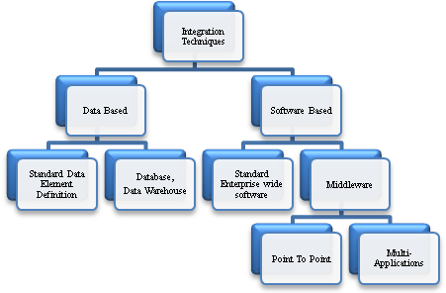
Figure 6. Integration Techniques
  - Data Based Integration Techniques
Those are techniques that relies on databases to present integration either by presenting unified standard data element definition, so all applications within the organization can share same data, or by presenting databases, and data warehouses as the organizational repository, and all running applications share same data repository.
By using either technique method, applications are integrated; unfortunately; only on database level. Several restraining forces against this technique are presented in the coming two sections.
    - Adopting Standard Data Element Definition
Custom software uses the same data element definitions as all other software within the system. Thus, uniqueness in syntax and semantics are presented.
One of the Software Architectures that fits this technique is: Pipe-And-Filter software architecture.
- Pipe and Filter Architecture: A very simple, yet powerful architecture, that is also very robust. It consists of any number of components (filters) that transform or filter data, before passing it on via connectors (pipes) to other components. The filters are all working at the same time. The architecture is often used as a simple sequence, but it may also be used for very complex structures. Figure 7 depicts mechanism of action of this software architecture [8,10].
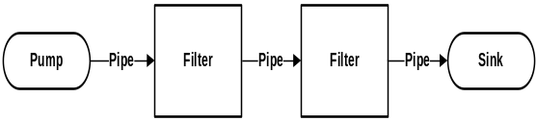
Figure 7. Pipe-And-Filter Architecture
Components of this architecture are:
- Pump: or producer is the data source. It can be a static text file, or a keyboard input device, continuously creating new data, or data of another application.
- Pipe: is the connector that passes data from one filter to the next. It is a directional stream of data that is usually implemented by a data buffer to store all data, until the next filter has time to process it.
- Filter: transforms or filters the data it receives via the pipes with which it is connected. A filter can have any number of input pipes and any number of output pipes.
- Sink: or consumer is the data target. It can be another file, a database, computer screen, or another application.
Applications share same standard data element definition, so, they can pipe data easily among them. By doing so, applications are integrated on data basis. Table 2 shows Driving and Restraining forces of Adopting Standard Data Element Definition as an integration technique, which unfortunately makes adopting databases and data warehouses not the perfect solution for process level integration.
Table 2. Driving and Restraining forces of Adopting Standard Data Element Eefinition
Driving Forces | Restraining Forces
Easier exchange o f data | Costs to develop standards definitions
Reduced development time | Costs to change existing systems
Reduced maintenance costs | Existing data definitions are different
 | Some definitions need to be different
 | Products use different data definitions
 | Lack of industry standard definitions
 | Mergers and acquisitions
    - Adopting Databases and Data warehouses
Database is a collection of persistent data that is used by the application systems of some given enterprise. Databases have too many advantages and they play an important role in today organizations. Benefits of data approach include sharing of data, and reducing redundancy [37]. Databases allow data to be shared, that means existing and new applications can share the data in the database. Databases reduce data redundancy by eliminating, or at least controlling redundancy. Data warehouse is the subject-oriented, integrated, nonvolatile, time variant data store in support of management’s decisions [38,39]. Data warehouse can be thought of as a collection of data from more than one data source (data sources include databases) for providing a single, quiet large repository for the entire organization. Databases and data warehouses have been widely used to integrate applications within organizations. Typical Data warehouse can be found in [40].
One of the Software Architectures that fits this technique is: Repository software architecture.
- Repository Software Architecture: The repository contains a single data structure, the Repository, and a number of modules called Knowledge Sources, that modify this data structure. These are the only characteristics of repository architecture [8,10]. Figure 8 depicts how repository architecture behaves.
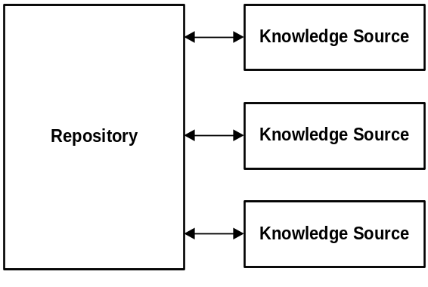
Figure 8. Repository Architecture
Table 3 depicts the driving and restraining forces of adopting databases and data warehouses as an integration solution, which unfortunately makes adopting databases and data warehouses not the perfect solution for process level integration. Unfortunately, there are restraining forces that make adopting databases and data warehouses not the perfect solution for internal and external organizational applications integration.
Table 3. Driving and Restraining forces of Adopting Databases and Data warehouses
Driving Forces | Restraining Forces
Easier access to enterprise wide data | Costs of development
Reduced development time | Different semantics in data sources
Reduced maintenance costs | Semantic translation
Minimal effect on operational system | Lack of industry standard definitions
Usage of Business Intelligence (BI) software | Deciding what data to warehouse
 | Delays in getting data to warehouse
 | Redundancy of data
 | Data quality issues
 | Brittleness of fixed record exchanges
 | Performance tuning
  - Software Based Integration Techniques
Another integration technique presented is the one based on using software as the orientation of integration solution. Either using standard enterprise wide software or presenting middleware is a software oriented solutions.
    - Standard Enterprise Wide Software
This means that whole organization uses the same software; this means that the whole organization is using the same data definitions, semantics, and formats for exchanging data. Enterprise Resource Plan (ERP) presents this technique as a solution to whole enterprise integration solution. ERP integrates Supply Chain Management System, Enterprise Management System, Customer Relationship Management System (CRM), e-commerce [41 – 43]. ERP providers list include Oracle [44], and SAP [45]. To provide a unified solution to the enterprise, layered architecture is required to enable integration of applications in different aspects.
Software Architectures that fit this technique include: Layered Systems, Client-Server, and N-tier architecture.
- Layered Systems: Layered Systems use layers to separate different units of functionality. Each layer only communicates with the layer above and the layer below. Each layer uses the layer below to perform its function. Communication happens through predefined, fixed interfaces. A Layer is a design construct. It is implemented by any number of classes or modules that behave like they are all in the same layer. That means that they only communicate with classes in layers immediately above or below their layer and with themselves. Figure 9 depicts layered systems architecture [10]. Each layer offers its own kind of functionality. A higher layer uses its lower layer to perform its function. It requires its lower layer. It is possible to define multiple layers at the same level. The user calls a function on an object in the upper layer. This object calls functions in the layer below. These functions in turn approach the layer below and the layer above. The primary disadvantage of layered systems is that they add overhead and latency to the processing of data, reducing user-perceived performance [46].
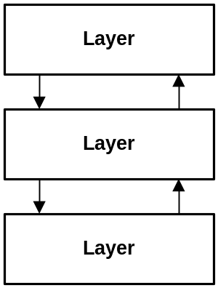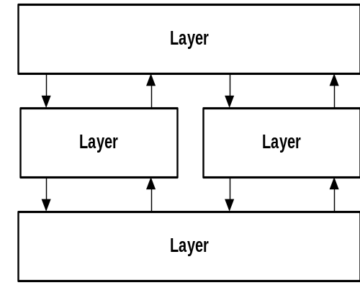
Figure 9. Layered Architecture Different Implementations
Another software architecture that ERPs heavily rely on integrating enterprise applications is the Client-Server and N-Tier architecture. A detailed SAP architecture based on N-Tier architecture is presented in [47].
- Client – Server Architecture: The client-server style is the most frequently encountered of the architectural styles for network-based applications [17]. Client - Server components are: Client triggers process, Server reactive process [48]. Clients make requests that trigger reactions from servers. Variety of Client – Server systems are surveyed in [49,50]. Client – Server architecture mainly consists of two layers: Single Server and many clients. Figure 10 depicts Client – Server Architecture different implementations. A Client-Server system is one in which the server performs some kind of service that is used by many clients [10]. The clients take the lead in the communication. The basic form of client-server does not constrain how application state is partitioned between client and server components, it is often referred to by the mechanisms used for the connector implementation, such as remote procedure call or message-oriented middleware [17].
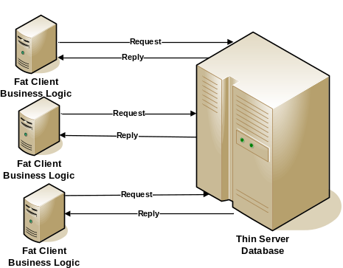
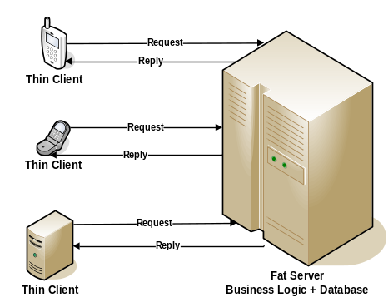
Figure 10. Client - Server Architecture Different Implementations
- N-Tier Software Architecture: N-Tier architecture is a Client-Server architecture combined with the Layered architecture where N equals three or higher [10]. Three-Tier architecture is an example of N-Tier architecture. Figure 11 depicts Three-Tier Architecture.
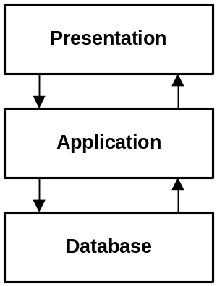
Figure 11. Three Tier Architecture
Three-Tier architecture consists of three layers: Presentation, Application, and Database.
- Presentation Layer: deals with user interactions. Thin clients interface do not contain business logic, just code required to process user input, send requests to the server, and show the results of these requests.
- Application Layer: processes client requests. It is the actual web application that performs all functionality specific to the web application. However, it does not store the persistent data itself. Whenever it needs data of any importance, it contacts the database server.
- Database Layer: contains Database and Database Management System (DBMS).
In the second and third tier there can be multiple instances, because of scalability, load-balancing and redundancy [10]. N-tier architecture (with N more than 3) is really 3 tier architectures in which the middle or bottom tier is split up into new tiers. Figures 12, 13, 14, and 15 present different implementations of N-Tier architecture.
Figure 12 shows the simplest implementation of Three-Tier architecture, where the most left layer that includes Smart Phone, Cell Phone, and PC presents required logic to display information and validate user inputs. Business logic ‘presented in applications’ required to provide web applications to users are present on the Business Logic server. Required data to support those applications are present in the Database server.
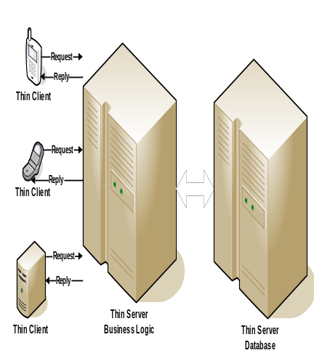
Figure 12. Three - Tier Architecture Implementation
Figure 13 illustrates the repetition of data layer by presenting more than one database server. Database servers can be connected together or separated. Business logic server can connect to both database servers, or connect to one database server incase database servers are connected together. Servers’ connections is an architectural decision that software architect shall consider while designing software architecture.
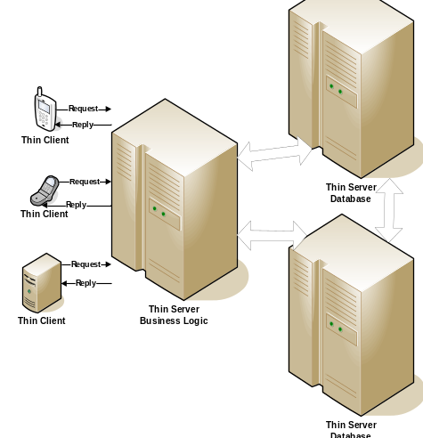
Figure 13. N-Tier First Implementation
Figure 14 presents another N-Tier implementation which replicates business logic servers. Scalability can force such a solution. Business logic servers can be connected to each other or not based on application requirements.
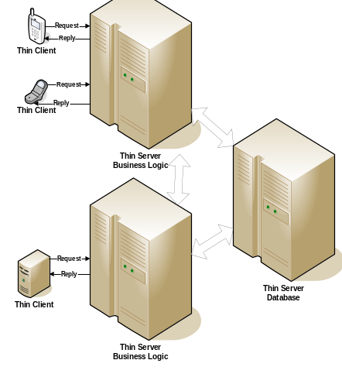
Figure 14. N-Tier Second Implementation
Figure 15 presents the third N-Tier implementation where business logic and database servers are replicated. Large scaled institutions require this type of architectures to face increasing requirements. N-Tier Architecture serves integration by forcing enterprises to implement standard software at each tier. Even if different software is implemented, by connecting each tier to the other, enterprises overcome integration problems. N-Tier has been widely accepted in today’s organizations as the standard architecture. Unfortunately, N-Tier architecture does not define what tier should include, how tiers should connect to each other, thus, architectural decisions still needs to be taken by software architect. Table 4 shows driving and restraining forces on adopting wide standard software as an integration solution. Unfortunately, this integration technique is not well suited for process level integration.
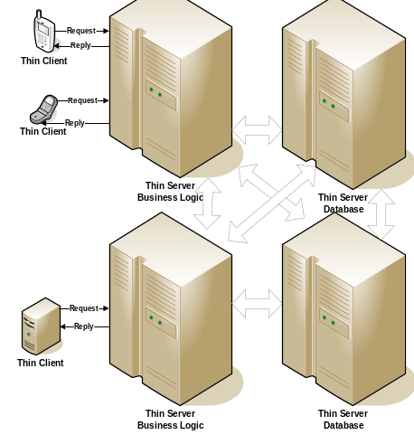
Figure 15. N-Tier Architecture Third Implementation
Table 4. Driving and Restraining forces of adopting Standard Enterprise Software – Adopted from
[125 – 127]
Driving Forces | Restraining Forces
Easier access to enterprise wide data | Mergers and acquisitions
Reduced development time | Departments have different needs
Reduced maintenance costs | Dependence on different software products
 | Conversion to new software
    - Middleware Integration Technique

Middleware integration facilitates communication between applications in order to exchange data and business logic. This communication is either: Point-To-Point, or Multi-Applications.

      - Point To Point Middleware
Point To Point refers to direct connection and communication between two applications. This direct communication can be presented by two methods: Adapters, and Remote Procedure Calls (RPCs).
- Application Adapters: In this case, a special purpose adapter is presented to integrate two applications and provide communication and exchange of data among them. Examples of adapters are presented in [51]. This adapter is capable of transforming data syntax and semantics, and managing communication among connected application. Special adapters are presented for each application.
- Remote Procedure Call (RPC): an RPC allows execution of program logic on a remote system by calling local routine. This calling is done via special message between client and server.

      - Multi-Applications Middleware
Multi-Applications middleware relies heavily on messages in order to hide complexity of communication between systems. It is not acceptable to provide adapters for the whole system; instead, a middleware is required to integrate applications within the system [36]. Exchanging messages enabled integration on software level. Table 5 depicts driving and restraining forces of adopting message routing integration technique.

Software architectures supported different implementations for integrating applications via exchanging messages. Those architectures include: Message Broker, Message Bus, and Broker.
Table 5. Driving and Restraining forces of Adopting Message Routing
Driving Forces | Restraining Forces
Consistent enterprise wide data | Costs of development
Reduced development time | Different semantics in data sources
Reduced maintenance costs | Semantic translation
Minimal effect on operational systems | Lack of industry standard definitions
 | Deciding what data to route
 | Delays getting data updates distributed
 | Data quality issues
 | Brittleness of fixed record exchange
- Message Bus: Message bus architecture connects all applications through the logical component known as Message Bus [28]. Message bus is responsible for delivering messages to destined applications. Sending application has no responsibility of direct connection with destined application. Sending application needs to prepare the message in the message bus agreed format, and delivers it to the message bus. Figure 16 depicts how message bus architecture works.
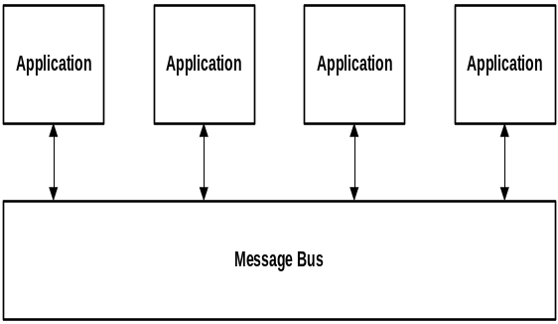
Figure 16. Message Bus Architecture
There are three options for subscribing the application to the Message Bus [52]:
- List-Based Publish/Subscribe: There are managed lists for subscribers. All subscribers receive certain messages when they are sent to the bus.
- Broadcast-Based Publish/Subscribe: Messages are sent to the all connected applications.
- Content-Based Publish/Subscribe: it enables Message Bus to investigate message contents to determine recipient of the message.
Limitations include that message bus can expose only one interface. In order for an application to be part of the architecture, it should implement the message bus interface, use the message bus messages type, and registers itself to the message bus. Performance issues are also a potential problem; poor application partitioning can create excessively high volumes of messages, and some use cases can be impacted through high network latency [53].
One of middleware integration technique’s implementation that utilizes message bus is CORBA.
- CORBA: is the acronym for Common Object Request Broker Architecture, OMG's open, vendor-independent architecture and infrastructure that computer applications use to work together over networks [54]. CORBA applications are composed of objects. CORBA creates a distributed objects infrastructure which makes activating and accessing remote objects transparent [55]. Legacy application is wrapped in code with CORBA interfaces and opened up to clients on the network. Systems wrapped with CORBA can be integrated under CORBA architecture. Table 6 depicts driving and restraining forces of adopting CORBA as an integration technique implementation.
Table 6. Driving and Restraining Forces of Adopting CORBA
Driving Forces | Restraining Forces
Interoperable networked applications | Different semantics in data sources
Reduced development time | Semantic translations
Reduced maintenance costs | Lack of industry standard definitions
 | Lack of CORBA/DCOM product support
 | Perceived CORBA/DCOM complexity
 | Effect on operational systems for up-to-the moment data requests
 | Merges and acquisitions
- Message Broker: The message broker can expose different interfaces to the collaborating applications, and it can translate messages between these interfaces [26]. Message broker does not enforce a common interface on the applications, thus handles shortages of Message Bus. Figure 17 depicts Message Broker architecture. Subscribing options are the same as mentioned in Message Bus architecture. Driving and restraining forces of adopting Message Brokers are presented in figure 17. Commercially, Message Broker is referred to as Message Oriented Middleware (MOM). One commercial implementation of MOM is Microsoft BizTalk Server [56]. Software Architectures that support Message Broker includes: Broker ‘Service Oriented Architecture’.
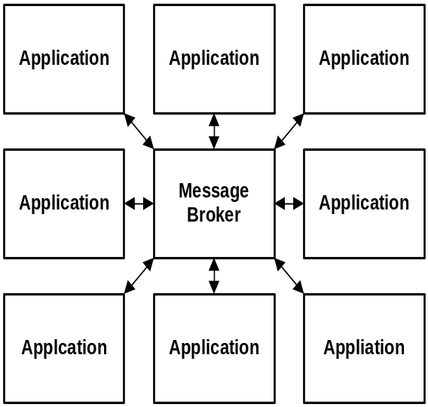
Figure 17. Message Broker Architecture
- Service Oriented Architecture (SOA): Servers can register and deregister with the broker. If a server fails, it will be automatically (after a timeout) unregistered by the broker. Broker handles user requests by providing user capability to find different service providers, pick the most suitable one, and utilizes its service [10]. The client requests a specific service. It formats its request in a specific format and sends it to its broker. The broker then selects the most suitable server to process the request. When the link between the client and the server is set up, they may start communicating directly, freeing the broker. Figure 18 depicts broker architecture mechanism of action.
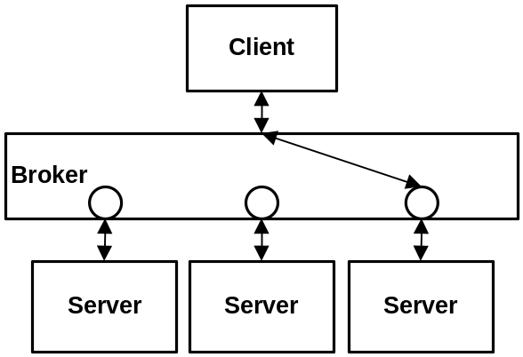Figure 18. Broker Architecture
CORBA was attempted to satisfy Broker architecture requirements, unfortunately CORBA itself has shortages that inhibited it from being the standard integration solution. Service Oriented Architecture is the most suitable architecture to integrate organizations on process level. Service Oriented Architecture integration is the strongest integration provided to organizations [33]. With this importance for Service Oriented Architecture, CORBA limitations were addressed among software vendors and industry standards creators. Web services were presented as the industry solution to overcome CORBA limitations. Table 7 depicts driving and restraining forces of adopting Web services as an integration solution.
Table 7. Driving and Restraining forces of Adopting Web services
Driving Forces | Restraining Forces
Interoperable networked applications | Different semantics in data sources
Emerging industry wide standards | Effect on operational systems for up-to-the moment data requests
Support of Web services in products | Standards are evolving, not fixed
Easier exchange of data
Reduced brittleness using tags
Reduced development time
Availability of external services
Availability of training and tools
Mergers and acquisitions
Semantic translation
With those driving forces mentioned for adopting Web services, and with the fact that Service Oriented Architecture being the only software architecture capable on providing a process level integration, combining both Web services and SOA is almost a must. Most software capabilities will be provided and consumed as services. When the service is abstracted from the implementation it is possible to consider various alternative options for delivery and collaboration models [96].
- Conclusion
Enterprise architecture is the framework of business, IT, information, and software architectures. Software architecture design is an important step within system design because software architectures should satisfy non-functional as it satisfies functional system requirements. Non-functional requirements like integration, interoperability, and agility can be satisfied by architectural design, if considered. Software architecture satisfaction to integration; as one of the non-functional requirements, is used in this chapter as an indicator to the software architecture of non-functional requirements satisfaction.
The most common Software architectures are mapped to presented integration techniques; highlighting architecture’s driving and restraining forces, and its satisfaction level to system non-functional requirements. Figure 19 summarizes the integration techniques and different software architectures presented as an enabler of each technique. Each one of the presented software architecture has its driving and restraining forces which presents strengths and weaknesses of each one. Web services based Service Oriented Architecture (SOA) achieved the maximum driving forces and satisfied almost all non-functional requirements addressed in the comparative study.
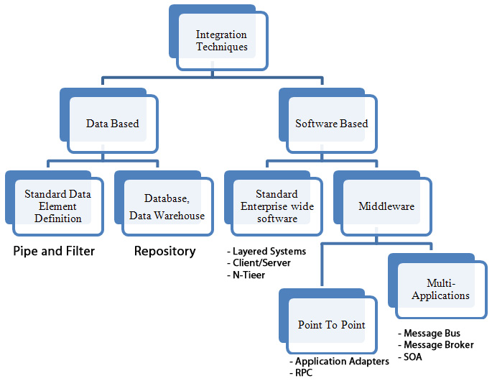
Figure 19. Integration Techniques and Software Architectures
- References
[1] A. Macaulay, “Enterprise Architecture Design and the Integrated Architecture Framework”, Microsoft Architects Journal, 2004, Vol. 1, pp. 4-9.

[2] S. T. Albin, “The Art of Software Architecture: Design Methods and Techniques”, John Wiley & Sons, 2003.

[3] L. Bass, B. John, and J. Kates, “Achieving Usability Through Software Architecture”, Software Engineering Institute, 2001.

[4] . L. M. Pittenger, “The IT Organization of the Future”, People Strategies, CMIT, 2001, http://www.commerce.virginia.edu/cmit/activities/Pittenger%20Presentation.ppt

[5] An Introduction to Enterprise Architecture, Arch2Arch, BEA, http://dev2dev.bea.com/pub/a/2006/03/enterprise-architecture.html?page=2

[6] Enterprise Architecture Seminar, Software Architecture Training and Consulting, Bredemeyer Consulting, 2004, http://www.bredemeyer.com/EnterpriseArchitecture/
Enterprise_Architecture_Seminar.htm

[7] L. Hohmann, “Beyond Software Architecture: Creating and Sustaining Winning Solutions”, Addison Wesley, 2003.

[8] A. M. Riad and H. A. El-Ghareeb, “A Service Oriented Architecture to Integrate Mobile Assessment in Learning Management Systems”, Turkish Online Journal of Distance Education - TOJDE April 2008, ISSN 1302-6488 Volume: 9 Number: 2 Article 12.

[9] Architectural Patterns, Enterprise Architecture Standards, Certification, and Services, The Open Group, http://www.opengroup.org/architecture/togaf7-doc/arch/p4/patterns/patterns.htm

[10] P. Bergen, Garfixia Software Architectures,
http://www.dossier-andreas.net/software_architecture/

[11] G. E. Krasner, S. T. Pope, “A Description of the Model-View-Controller User Interface Paradigm in the Smalltalk-80 System”, ParcPlace Systems, Inc., 1998, http://www.ccmrc.ucsb.edu/~stp/PostScript/mvc.pdf

[12] C. Calvary, J. Coutaz, and L. Nigay, “From Single-User Architectural Design to PAC: a Generic Software Architecture Model for CSCW”, Atlanta, Georgia, ACM, 1997, CHI 97 Electronic Publications.

[13] D. L. March, IT533 - SOFTWARE ARCHITECTURES - CLASS 3 - PIPE-AND-FILTER STYLE, Academic Computer Center, DeSales University, 2003.

[14] F. Bachmann, “Software Architecture Documentation in Practice: Documenting Architectural Layers”, Software Engineering Institute, Carnegie Mellon, 2000.

[15] H. L. Muller, “Parallel evaluation of a parallel architecture by means of calibrated emulation”, Parallel Processing Symposium, Proceedings, Eighth International, 1994 Vol. 26, pp. 260 - 267.

[16] F. Buschmann, ”A System of Patterns – Pattern-Oriented Software Architecture”, John Wiley & Sons Ltd, 1996.

[17] Client/Server and the N-Tier Model of Distributed Computing, N-Tier.com, Micromax Information Services, 2001, http://n-tier.com/articles/csovervw.html

[18] R. T. Fielding, “Architectural Styles and the Design of Network-based Software Architectures”, University of California. Irvine, 2000.

[19] J. Hunt, ”Blackboard Architectures”, JayDee Technology Ltd., 2002.

[20] J. Brownlee, “Finite State Machines (FSM)”, AI Depoit, http://ai-depot.com/FiniteStateMachines/

[21] S. Mary, “Beyond Objects: A Software Design Paradigm Based on Process Control”, ACM Software Engineering Notes, 1995, Vol. 20, pp. 27-38.

[22] Liverpool University, http://www.csc.liv.ac.uk/~mjw/

[23] Object Request Broker, Software Technology Roadmap, Carnegie Mellon, http://www.sei.cmu.edu/str/descriptions/orb.html

[24] F. Buschmann, “Pattern: Master-Slave”, Vico.org - Open Modeling, 2000.

[25] B. P. Douglass, “Real-Time Design Patterns: Robust Scalable Architecture for Real-Time Systems”, Addison Wesley Professional, 2002.

[26] Message Broker, MSDN: Microsoft Digital Subscriber Network, http://msdn2.microsoft.com/en-us/library/ms978579.aspx

[27] Message Bus, MSDN: Microsoft Developers Network, http://msdn2.microsoft.com/en-us/library/ms978583.aspx

[28]. G. D. Abowd, “Structural Modeling: An Application Framework and Development Process for Flight Simulators”, Software Engineering Institute, Carnegie Mellon University, 1993.

[29] M. Ripeanu, “Peer-to-Peer Architecture Case Study: Gnutella Network”, Department of Computer Science, The University of Chicago, 2001.

[30] D. S. Linthicum, “Next Generation Application Integration: From Simple Information to Web Services”, Addison-Wisely, 2004.

[31] T. Erl, ”Service Oriented Architecture: Concepts, Technology, and Design”, Prentice Hall, 2005.

[32] A. M. Riad and H. A. El-Ghareeb, “Aligning Service Oriented Architecture and Business Process Management Systems to achieve Business Agility”, Egyptian informatics Journal, Cairo University, 2008, Vol. 9, Issue 1.

[33] P. Bernus, and M. Fox, ”Knowledge Sharing in the Integrated Enterprise: Interoperability Strategies for the Enterprise Architect”, Springer, 2005.

[34] Developing Agile Organizations: Skills for Managers and Team Leaders, Gower, http://www.gowertraining.co.uk/docs/agile.pdf
[35] G. Hohpe, and B. Woolf, “Enterprise Integration Patterns: Designing, Building, and Deploying Messaging Solutions”, Addison Wesley Professional, 2003.

[36] D. K. Barry, “Web Services and Service-Oriented Architecture: The Savvy Manager's Guide”, Morgan Kaufmann Publishers, 2003.

[37] C. J, Date, “An Introduction to Database Systems”, Addison Wesley, 2004.

[38] J. Hurwitz, “Service Oriented Architecture For Dummies”, Wiley, 2007.

[39] W. H. Inmon, “Building the Data Warehouse”, Wiley, 2005.

[40] T. Connolly, and C. Begg, ”Database Systems: A Practical Approach to Design, Implementation and Management”, Addison-Wesley, 2004.

[41] D. N. Chorafas, “Integrating ERP, CRM, Supply Chain Management, and Smart Materials”, CRC Press, 2001.

[42] S. Harwood, “ERP: The Implementation Cycle”, NetLibrary, Inc, 2003.

[43] C. A. Ptak, “ERP: Tools, Techniques, and Applications for Integrating the Supply Chain”, Second Edition, CRC Press, 2003.

[44] Oracle E-Business Suite, http://www.oracle.com/applications/e-business-suite.html

[45] SAP: Business Software Solutions Applications and Services, http://www.sap.com/index.epx

[46] D. Clark, and D. Tennenhouse, ”Architectural considerations for a new generation of protocols”, Philadelphia : ACM 1990, ACM SIGCOMM`90 Symposium. pp. 200-208.

[47] G. Anderson, and D. Larocca, “Sams Teach Yourself SAP™ in 24 Hours, Second Edition”, SAMS, 2005.

[48] G. Andrews, “Paradigms for process interaction in distributed programs”, ACM Computing Surveys, 1991, Vol. 23, pp. 49-90.

[49] A. Sinha, “Client-Server Computing”, Communications of the ACM, 1992, Vol. 35, pp. 77-98.
[50] J. Waldo, G. Wyant, A. Wollrath, S. Kendall, “A note on distributed computing”, Sun Microsystems Laboratories, 1994.

[51] Applications Adapters, IBM Software - WebSphere Adapters, http://www-304.ibm.com/jct03001c/software/integration/wbiadapters/apps/

[52] Publish/Subscribe, MSDN: Microsoft Digital Developers Network, http://msdn2.microsoft.com/en-us/library/ms978603.aspx

[53] S. Hoare, “Schools of Enterprise Application Architecture: Semantic Arts - Enterprise Architecture Development and Application Integration”, Semantic Arts, 2003.

[54] CORBA Basics, OMG: Open Management Group, http://www.omg.org/gettingstarted/corbafaq.htm

[55]. M. Brake, “Explaining CORBA”, Colorado State University, 1998.

[56] BizTalk Home - Your Business Connected, http://www.microsoft.com/biztalk/default.mspx

Bibliography

A. M. RIAD, Head of Information Systems department in Faculty of Computers and Information Systems in Mansoura University. Graduated in Mansoura University from electrical engineering department in 1982. Obtained Master degree in 1988, and Doctoral degree in 1992 in Electrical Engineering. Main research points currently are intelligent information systems and e-Learning. http://www.amriad.com

Hazem M. El-Bakry, Doctor and Lecturer in Information Systems department in Faculty of Computers and Information Systems in Mansoura University. Received the B.S. degree and the M.S. degree in electrical communication engineering from the Faculty of Engineering, Mansoura University, Egypt, in 1992 and 1995, respectively and PhD. at the Multimedia Device Laboratory, University of Aizu, Japan.

Haitham A. EL-Ghareeb, Associate Teacher; Information Systems Department, Faculty of Computers and Information Sciences, Mansoura city University, Egypt. Interested in e-Learning, Software Architecture; specially Service Oriented Architecture (SOA), and Business Process Management (BPM). Hold a Bachelor Degree (2004) and Masters Degree (2008) from the same faculty working on. Master thesis was entitled “Evaluation of Service Oriented Architecture in e-Learning”. Currently, a PhD. student in the same faculty and working in “Supporting e-Learning with Adaptive and Intelligent Features”. Information about publications, activities, and personal blog are available at the Web site: http://www.helghareeb.net

Persistent Data are data that once accepted by DBMS for entry, can subsequently be removed only by some explicit request to DBMS.
Enterprise is simply a convenient generic term for any reasonably self-contained commercial, scientific, technical or other organization.
Nonvolatile means that, once inserted, data cannot be changed, though it might be deleted.
In this case, machine who initiated RPC is considered Client, while the machine that holds code to be invoked and executed by reception of RPC is Server.

